Name:___________________
Sheep Brain Dissection
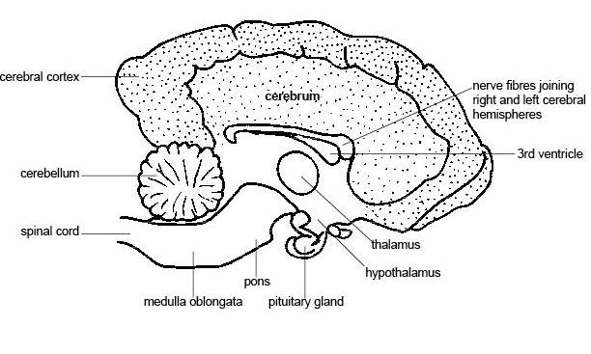Materials: newspaper, scalpel, a sheep brain, a dissecting tile, gloves and a blunt seeker.
Procedure:
1. Before you cut the brain up put it on the dissecting tile with the cerebrum facing up.
Describe the surface of the cerebrum.

2. Cut the brain down the middle so that the hemispheres are separated.
Lay the two sides so that the cut inside of the brain is facing up.
What do you notice about the colour of the outside of the cerebrum compared to the inside?

3. Find the cerebellum and the brain stem
4. Draw a side view of the sheep brain. Label the cerebrum, cerebellum and brain stem.

5. Wrap the bits of chopped up brain in your newspaper and put in in the bin liner. Put your instruments into the methylated spirits in the beaker. Put the gloves into the bin. Rinse the tile and place it in the tray at the front.

Questions
1. List two ways the sheep brain would be different to a human brain.

2. What does the cerebrum do?

3. What does the cerebellum do?

4. The brain and the spinal cord make up the C__________Nervous System.

